**Maintenance Schedule**

#Additional Menu

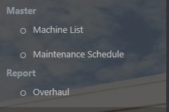

#Schedule From

Before (Excel Format)

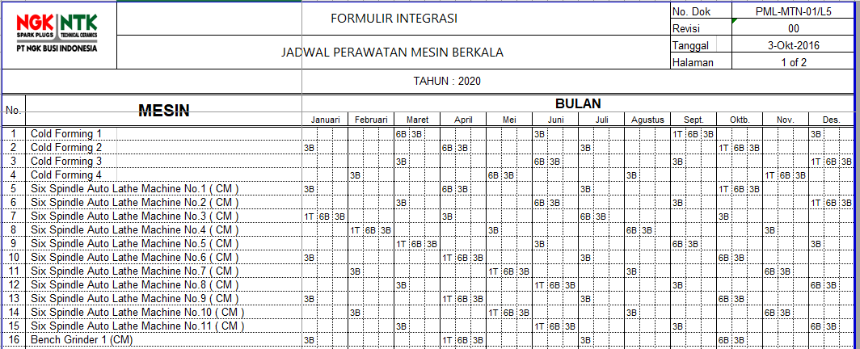

After (Website)

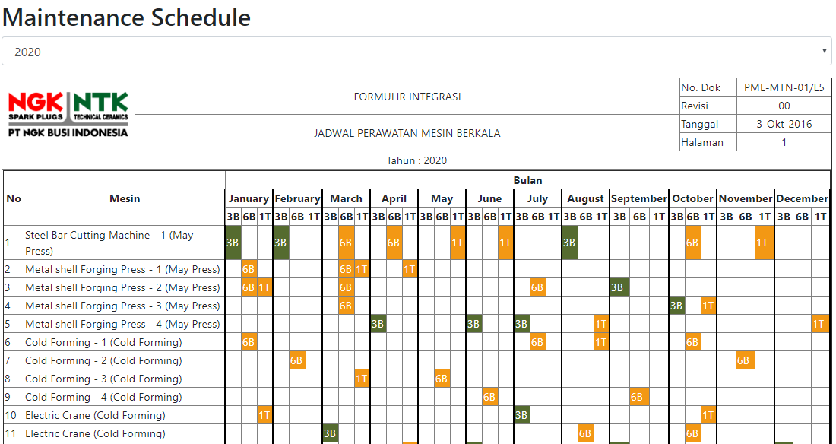

* As much as possible not to change the form(same as original), so the user already familiar with the form.
* User only need to click the empty box to set/unset the schedule
  +  🡪 The Schedule Already Done
  + 🡪 The Schedule Not Done Yet



* By fill the “Maintenance Checklist” form, the status will be turn green automatically

**Maintenance Checklist**



* By Clicking the machine name, user will be redirected into the maintenance form

Before(Excel Format)

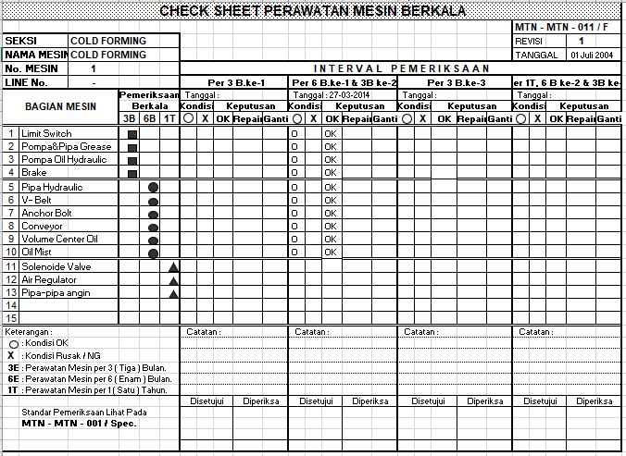

After (Website Format)

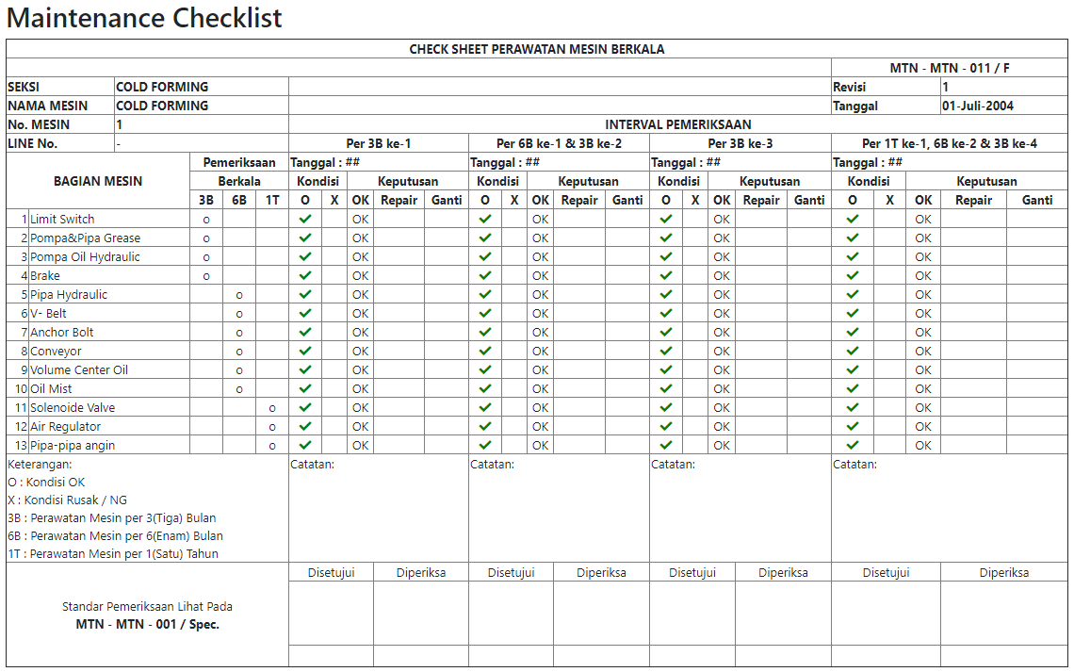

* As much as possible the form also same with the original, so the user already familiar.
* The item data list is based from the data that PE PIC Send.
* The user only need to click the form to ‘check’ it.

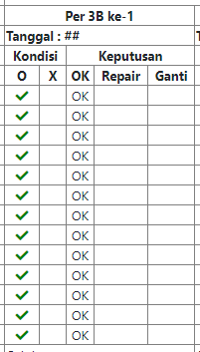

* For the approval, the user only need to click the “sign” icon

